University of Engineering and Technology, Lahore
Name: Maria Abbas
Reg No: 2026(S) CYS_61
Department: Computer Engineering
Degree: Cyber security
Section: B
Assignment: PF Lab week 14
Date: 1 June 2026
CLO2
Lab Tasks
OS Library, if_name_==”_main_”, is vs ==
Task 1
1. OS Library
The os module in Python allows you to interact with your operating system (like creating folders, checking paths, and listing files).

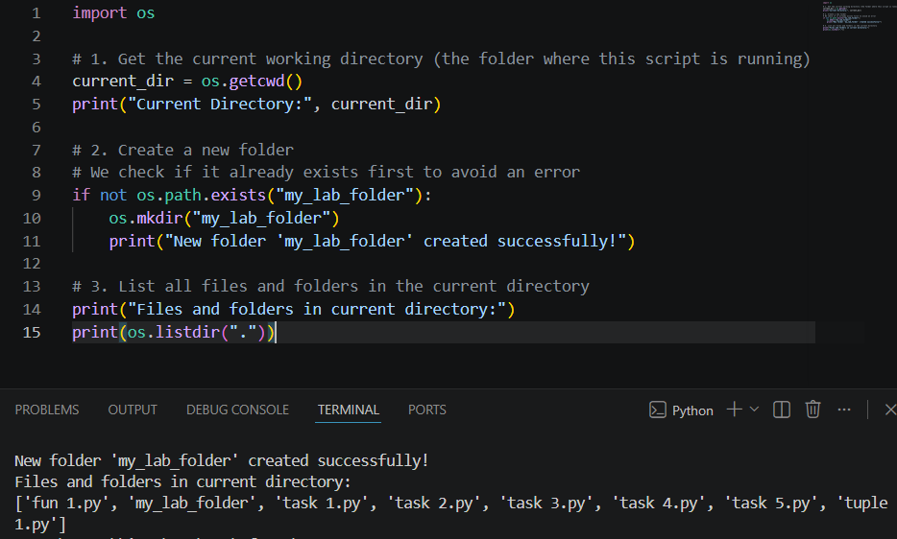
Task 2:
2. if _name_ == "_main_":
This statement is used to determine whether the Python script is being *run directly* or being *imported* as a module into another script.
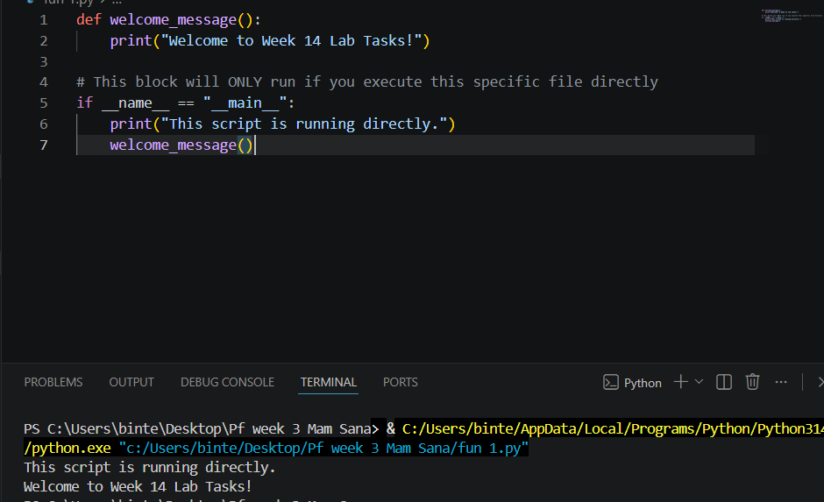
If you run this file directly, it will print the message. If you import this file into another Python file, the code inside the if block will be ignored until you explicitly call the function.

Task 3:
3. is vs == (Comparison Operators)
* == checks if the *values* of two objects are equal.
* is checks if the two variables point to the *exact same object in memory* (Identity).
